**AEEM 6099 Systems Engineering & Analysis**

**Shopping Assistant System**

**Yufeng Sun**

**2019-Spring**

**Milestone I - Prepare (part 1 of) a (3-part) report that includes the following:**

1. Title page with:
   1. Original project name
   2. Team number ***and*** names of all team members
   3. Brief description of the project (just 3 sentences)
2. Summary page that states the following information:
   1. Who you are acting as for this project (e.g., R&D group at NASA, company like SpaceX, etc.)
   2. Who your customer is
   3. What problem you are trying to solve
   4. What the system-of-systems context of this (potential system /) problem is
   5. What the goals / objectives are
      1. DO NOT give a potential final solution – that’s jumping to the end without performing a systems engineering analysis!
      2. Instead, give the overall desired outcomes (as in, how you would know that the problem has been solved = you are seeing these things having occurred; goals have been met 🡪 problem solved!)
         1. this will help you determine requirements and metrics later
3. Motivation page that gives the following information:
   1. For each team member, answer the following questions (giving the personal views of each of the team members):
      1. Why did you choose this particular project?
      2. Why is this of importance to you?
   2. For the entire team, answer the following question:
      1. What is the main motivation / justification from the community’s perspective?
4. System operational requirements and maintenance concept:
   1. Operational requirements and maintenance concept for the system
      1. Develop the operational requirements for that system. (Refer to Section 3.4 and pay close attention to Section 3.4.1 – you should be covering all seven areas. See Section 3.4.2 for examples.)
      2. Based on these results, develop the maintenance concept for the system. (Refer to Section 3.5 – you should be covering all six areas.)
   2. Operational flows for the system (figures / diagrams with explanation)
      1. This ties back to maintenance concept, include figures such as 3.14.
   3. Maintenance flows for the system (figures / diagrams with explanation)
      1. This ties back to maintenance concept, include figures such as 3.14.
   4. Repair policies for the system (figures / diagrams with explanation)
      1. This ties back to maintenance concept, include figures such as 3.16.
   5. Apply quantitative effectiveness factors as appropriate. (See Section 3.4.1, “Effectiveness factors” for examples.)
5. Context of your system’s function in the larger system-of-systems:
   1. Community infrastructure (figure / diagram with explanation)
      1. For your own system, develop a figure – and associated explanation of the assumed existing infrastructure that you will be drawing upon – similar to Figure 3.12 (page 73).
         1. Identify the various system capabilities (functions).
         2. Illustrate (draw) an overall configuration structure (similar to that in the figure) and explain what similar infrastructure exists in your own community that you will be assuming exists already that you and/or your system can depend upon.
         3. Identify some of the critical metrics required as an input to the design as appropriate. (This may include metrics similar to those given on page 74, but tailored to the local configuration.)
   2. Functional flow diagram (figure / diagram with explanation)
      1. For your system, develop a lower-level figure – and associated explanation – similar to Figure 3.22 (page 88) that helps better define some of the lower-level functions required.
   3. S.O.S. configuration (figures / diagrams with explanation)
      1. For your own system, develop a figure – and associated explanation of the critical requirements – similar to Figure 3.13 (page 75).
         1. Describe how this ties back to the operational requirements
         2. Describe how this ties back to the maintenance concept
         3. Describe the significant technical performance measures (TPMs) for each of the major systems in the overall configuration. (Note: TPMs are discussed in several parts of the textbook, including Sections 2.4.1, 3.6, and 5.8.)
      2. For your own system, develop a figure – and associated explanation of the functional interfaces of the S.O.S. configuration – similar to Figure 3.24 (page 91).
         1. Identify some of the more critical interface requirements (interoperability requirements).
         2. Identify some of the potential problem areas (if any).
6. Customer, System, and Design Requirements, and RAS with traceability:
   1. Develop a set of requirements using a similar format to the mousetrap example (see the AIAA Systems Engineering pdfs, especially starting at slide/page 40 of "AIAA SE_Short Course_Jan 2012 -- Day 13.pdf"):
      1. Customer Requirements
         1. slides/pages 28 and 30 is a good starting point
         2. slide/page 40 gives the specific mousetrap example
      2. System Requirements
         1. slide/page 40 gives the specific mousetrap example
      3. Design Requirements
         1. slide/page 41 gives the specific mousetrap example
      4. Requirements Allocation Sheet (RAS) ***and*** Requirements Flow Down Verification and Integration
         1. slide/page 63 is an example of combined RAS + V&I
      5. Requirements Traceability ***and*** Requirements Traceability Matrix
         1. "AIAA SE_Short Course_Jan 2012 -- Day 13.pdf", slides 46-53
            1. Longitudinal traceability example: link between a requirement and a verification procedure/information
            2. Lateral traceability example: link between (prototype or other design) model and (generally a derived) requirement that is linked back to the larger model (environmental, subsystem, system) or trade study ***or*** link to external specification(s) that were determined by some evaluative (modeling) process

Milestone  M1  (Grade)

1. Proj name (1), team number (1), member names (1), 3-sentence description (2)  --> 1 (5pts)  --> 4

2. Who you are, who customer is, problem trying to solve, SoS context, goals + objectives (/ desired outcomes) (5pts ea)  --> 2 (25pts)  --> 24.9

3. Motivation (each member (10 total), community (5))  --> 3 (15pts)  --> 15

4. Operational requirements (7 areas, 10pts), maintenance concept (6 areas, 10pts), op. flow (10), main. flow (10), repair policies (5), quant. effectiveness factors (5)  --> 4 (50pts)  --> 34.95

5a. Community infrastructure (identify system capabilities/functions (5), overall configuration structure (Fig, 3.12 pp73) (5), critical metrics (5))  --> 5a (15pts)  --> 8.75

5b. Functional flow diagram Fig 3.22 pp88  --> 5b (5pts)  --> 4.9

5.c.i. SoS Configuration (figure Fig3.13 pp75  (5), op.req.s + maint. tie-back (5) + TPMs (5))  --> 5.c.i (15pts)  --> 7

5.c.ii. SoS Configuration (figure Fig3.24 pp91 (5), critical interface requirements &/or problem areas if any (5))  --> 5.c.ii. (10)  --> 10

6. Requirements Description & Rationale (using AIAA Mousetrap format) (Customer R (5), System R (5), Design R (5), RAS + R Flowdown V&I (5), R Traceability (+Matrix) (5))  --> 6 (25pts)  --> 24.8

--  --> HW total  --> 134.3

--  --> Out of  --> 165

--  --> Percent Grade  --> 81.39393939

# 1. Project Description

This project proposes a shopping assistant system aiming to help international tourists achieve a better shopping experience in big malls like Super Brand Mall (SBM) Shanghai. A mobile system integrating with information service will be developed for assisting the international tourists to do shopping in big malls. Thus, the system will be able to provide convenience to international tourists by saving their time on searching the right information and physical energy of carrying shopping bags.

# 2. Project Summary

## 2.1 Name:

Shopping Assistant System

## 2.2 Team:

Company “YY” (Service Solution Provider)

## 2.3 Customer:

International Tourists (in big malls)

## 2.4 Problem to Solve:

International tourists usually have a tight schedule and waste a lot of time on searching right information, even lost their way in big malls as they are in a strange place surrounding by people who do not speak their native language. This project is aiming to improve the shopping experience of international tourists in big malls, like SBM Shanghai by making their shopping convenient and efficient. And the same solution could be applied to public places where the international tourists usually visit, such as airport, train station, and amusement park.

## 2.5 System-of-systems Context:

This project will develop a system for providing unique experience to international tourists, and will benefit big malls, airports, train stations who want to attract more international tourists, and help differentiate them in the competition. Further, the city image is like to be improved.

## 2.6 Goal and Objectives:

The goal of this project is to build a system to help improve the shopping experience of international tourists in big malls like SBM Shanghai by making their shopping convenient, time saving and physical energy saving. The system shall be easy to be interacted with to reduce the wasting effort caused by communication in different languages, finding the right information of desired product and service, finding the correct position of the store they want to go and carrying the heavy bags during long hour shopping.

# 3. Motivation

## 3.1 Yufeng Sun

I am a student in AEEM and my research interest is robotics. I choose this project because I would like to practice the system thinking in my interested area. This practice will benefit my study and research on robotics in future.

## 3.2 Yuhan Liu

As a customer usually shopping in Big Mall and find it hard to find some spots inside and search information about products, I choose this specific project to solve this problem I interested in. Since I took the robotics course, I have a lot of interest in this field and I believe it will practice my system thinking skills as my track is system engineering.

## 3.3 Team

There are billions of international tourists travelling around every year, for example, the Super Brand Mall (SBM) Shanghai has 6 million oversees customer in year of 2018, the huge tourism market is the background of this project.

Today’s shopping malls are shifting their roles to service providers in order to survive in the competition with online shopping and other shopping malls, such big malls usually require a lot of time to explore, and the complexity of internal environment makes the shopping time consuming to millions of international customers. For example, SBM Shanghai is a huge mall with 13 shopping floors and more than 400+ brands. The place is a hive of activity with many options for food and entertainment. Thus, it requires a lot of time to explore the places. Wide range of options attracts customers, however saving time is one of the main purposes of customer to do shopping in a mall. In addition, language service is one of the important factors that international tourists will consider for choosing a shopping destination. So, we think the shopping experience of millions of international tourists could be improved by using some kinds of system that could assist them to do shopping.

# 4. System Operational Requirements and Maintenance Concepts

In this project, we (Company YY) are responsible for designing, constructing and deploying the shopping assistant system.

## 4.1 Operational Requirements

The operational requirement for the shopping assistant system could be categorized as follows:

### 4.1.1 Mission definition

**Prime mission**

The prime mission of this project is to develop a shopping assistant system integrating with information search functionalities which is aiming to improve experience of international tourists when they are doing shopping in big malls, like SBM Shanghai.

International tourists usually have tight schedule, the shopping assistant system shall be used to address the main problems during their shopping in the big mall. The system will be integrated with advanced user interaction system to process end-users’ requirements, such as navigating them to stores or any other spots in the mall where they want to go, providing plenty information about products and services when they give a search criteria and providing interaction in their native language. And the system shall be developed to be able to carry end-users’ bags. With these functionalities, the system will be able to make the shopping experience of end-users more convenient and efficient.

**Dynamics of operating conditions**

* Complex environment

Big malls are places where may have floors and escalators, and sometime may be crowded, the shopping assistant system shall be light-weight and in appropriate small size so that it can be maneuvered conveniently without introducing troubles. And it should be easy for end-users to access, to rent and to return during their whole shopping time.

* Different requirements from end-users.

International tourists may have different requirements on the system, someone may want to use most of the functionalities and someone may only use one of these functionalities. So the system should be developed to be flexible to satisfy different requirements without introducing other troubles.

* Information update

International tourists require information that is accurate and updated, so the system shall be able to provide latest information related to the products, services and facilities to the end-users.

* Unexpected usage

End-users may leave the device along while they are doing other things, the device shall be able to track the end-user, and be able to send a warning or a reminder to the end-user once they are far away from each other or in an unexpected situation.

### 4.1.2 Performance and physical parameters

As the shopping assistant device will be developed to help international tourists save their time and make their shopping convenient, there are some critical parameters that need to be monitored to ensure that the device is functioning as it is designed to. Briefly listed as follows:

* Mean time between failures (MTBF)
* Mean time to respond (MTTR)
* Speed of autonomous run
* Tracking distance
* Accuracy of navigation
* Payload
* Battery life
* Weight
* Size

In order to make the system easy for end-users to access, the MTBF and battery life will be monitored and make sure the devices are able to run during the business hours without any failures. The Speed of autonomous run and tacking distance will help end-user in the scenario that they are busy on other things and don’t manually control the device. Accuracy of navigation will save the time of finding the stores or places that the end-users want to go. And the payload will be designed to maximize the capability of carrying bags for the normal cases. The MTTR is the indicator of how software system work and will be important to the user experience for the interaction with the system, the system should respond to users’ input in a reasonable time. The weight and size will determine how user to maneuver the device when they switch the autonomous mode to manually control mode in some complicated situations where the device cannot perform autonomous move.

### 4.1.3 Operational Deployment / Distribution

* Quantity of equipment - 100~200 shopping assistant device is almost enough for the Super Mall like Super Brand Mall (SBM) in Shanghai which has 600 million tourists per year. As not so many people will buy things in the mall and if only 10% (which is very high as usual) of customers want to use that, the quantity of our devices is enough to cycle use during the opening time of the super mall. And the normally use time of every device is about at least 5 years before sending back to recycle.
* Software - There are three distinct systems which need different software. The high-level overview of these software are:
* The shopping assistant device use this drive control system for moving following the customers automatically. It may need Bluetooth in every device. It can do contribution to customers’ shopping more convenient and relax.
* The service system of the devices can give several kinds of service to customers including navigation, searching information, translation which need different software like GPS for navigation.
* Software in the device should be interaction system to make connection with end-users and let customers easily use it. As the device should provide voice service during the experience customers using it, like navigation, translation, end-users can easily get response by connecting the Bluetooth headset.

* Personnel required – There should be a training to the personnel in the SBM Shanghai, help them to know the basic operational knowledge of the device to avoid the situation that some customers have questions about how to use the devices. Also, they should provide service to customers in case they return the device everywhere and it did not move to the nearest station on the same floor. What’ more, if the device be broken or has any other problems, they could manage and return them to maintenance shop to repair.
* Expected geographical location - The device should be easy to access so these should be mainly put in front door of mall and underground parking stations which can be easily get and return when customers get out and into the mall. Also, to guarantee the availability of the device, the mall should put stations in every floor to let customers return the devices very conveniently. To make end-users have the service which quickly add the time to continue using it, the device should provide easy way for customers to pay using card and include different time plan for customers to use at first. It could charge immediately and automatically when it is returned to any stations and stay here between 10 pm to 10 am.
* Distribution of software - There may be all the three kinds of system of software on every dependent device to support and manage the interaction of the device including navigation, translation, and information searching. It is very important that all the devices share store information in mall and update it by the same network platform.

### 4.1.4 Operational Life Cycle

**Program schedule**

|  |  |
| --- | --- |
| System phase | Timeline |
| Phase I System Research and Development | 1.5 years |
| Phase II System integration and test | 3 months |
| Phase III Construction and Assembly | 4 months |
| Phase IV System deployment | 1 month |
| Phase V Operation and maintenance | 5 years |
| Phase VI Recycle and disposal | 4 weeks |

**Total inventory profile through life cycle**

We will make 200 devices in phase I and test all the devices before deploying. We will deploy 150 devices to SBM Shanghai with distributing them to 7 floors. The other 50 devices will used as replacement during maintenance.

**Who will be operating the system?**

We (Company YY) will responsible for the system planning and design. Once the design and development are completed, a 3rd party manufacturer will be involved for fabrication and we will co-work with the 3rd party manufacturer for the details of the devices, such as the material, hardware etc. A software company will be involved as the software system vendor. After the device is completely built and software system is developed, we will install the software system on the device and test the device in the testing environment where is for simulating typical situations in the mall. After the devices pass the test, they will be deployed to SBM Shanghai, and there will be some trainings about how to use the device and do daily maintenance for staff from the mall as they will be responsible for the daily operation and maintenance on the system. Once the devices are broken or unable to use, they will be sent back to us, and we will check and repair them, or simply replace the devices. We will decide if the devices need to be disposed based on the level of damage. If the devices cannot be repaired and need to be disposed, they will be sent to a 3rd party vendor who is for recycling and disposal.

### 4.1.5 Utilization Requirements

The devices shall be used in business hours of the mall, typically from 10:00am to 10:00pm, 12 hours in total. So, the devices shall be fully functional during this period. Daily maintenance will be scheduled in 10:00pm to 11:00pm after the business hours.

Once end-users enter in the mall, on the main entrances, they shall find these devices easily. With easily paying for rent, they could unlock the device and start their shopping. The devices shall have two control modes, one is for manually control when the surrounding situation is complicated, and the other is for autonomous move when the surrounding situation is simple and clear. The devices shall be able to track the distance between itself and end-users in case of the end-users are too far away from the devices or in some other unexpected situations. The devices shall be able to send a warning or reminder to the small piece receiver hold by the end-users. Once the end-users want to stop shopping and leave, it shall allow them to drop the device to the nearest appropriate spot by simply returning the receiver to the device which means the end-user is leaving.

The device shall be able to check the status of itself. If it is not in use, it shall be able to find the nearest spot and autonomously move itself to that spot (usually on the same flow). In case there are too many devices in one floor, the staff in the mall will redistribute devices to other floor. All these works are for ensuring that the devices are available and easy for end-users to use.

### 4.1.6 Effectiveness Factors

* Cost system effectiveness

As we want to make money from this project, we have to design a cost-effective system. That means, we need save our cost in research and development stage, and the equipment of the system should be cost-effective too. The maintenance of the system should not cost too much.

Total cost of the project should not exceed 3 million US dollars, and cost of the equipment should not exceed 1000 US dollars. The system cost will impact the rent rate, we will try to low our rent rate, so that most of the customers can afford.

* Operational availability

As the system should be accessed easily by customers, it should be available 12 shopping hours daily, that includes the availability of equipment and the software services in the daily shopping time. And for recharging system, it should be available 24 hours a day, usually, the recharge will go on night, but in case some of the equipment are in low level battery, they should be able to recharge in the daily time.

* Failure rate

The failure rate is a good indicate of the robustness of our system, as all the unit have probability of fail, we need to build a low rate fail system, by design and chose the right unit, that includes the mechanical part of the equipment, the battery, the software system and the hardware network in the system. we need to give a criterion for each of the component, hence, to conduct a system failure rate, and ensure the system rate is acceptable by testing. So that customers can have a better experience when they are using the system.

* Operator skills

The system should be designed for customer easy to use, but in case there are some failures during operation, we need some personnel in the mall to support, so we have to train some employees in the mall for how to give support and maintenance in case the system is failed to be operated.

### 4.1.7 Environment Factors

The big malls like SBM Shanghai usually contain floors and escalators, and sometime are crowded. The device shall have capability to handle the different situation. So, the device shall be developed to have two control modes, one is autonomous control which is for release the hand of the end-user and keep following the end-user by tracking the distance between itself and the end-user. The other is manually control which is for the complicated surrounding situation and end-user could manually control the device, when they are riding the escalator or elevator, or in a narrow place.

And the device shall be able to detect obstacles when it is in autonomous control mode.

## 4.2 Maintenance Concepts and Repair Policies

### 4.2.1 Major level of maintenance

|  |  |  |  |
| --- | --- | --- | --- |
| **Criteria** | **Organizational Maintenance** | **Intermediate Maintenance** | **Supplier/Manufacturer Maintenance** |
| *Done where* | SBM Shanghai, the Mall which is the operation site | Company YY | 3rd party vendors |
| *Done by whom* | Staff from the mall | Technical support department | Staff from 3rd party vendors |
| *On whose equipment* | On the device and the mall’s equipment for paying and charging the battery | On the device and the equipment for update the software system | On the device and the equipment of 3rd party vendors |
| *Type of work accomplished* | · Clean  · Redistribute  · Charge the battery  · Test functionalities  · Change battery  · Change specific parts | · Update software system remotely  · Check and test the functionalities of the device generally | · Repair the hardware  · Repair the mechanical parts  · Fix software system bugs  · Disposal  · Recycle |

### 4.2.2 System maintenance and repair policy

|  |  |  |
| --- | --- | --- |
| System | Company YY | Supplier and Manufacture maintenance |
| Unscheduled maintenance   * Faulty unit isolated in mechanical part of robotic cart, tablet and hardware system * Report the faulty unit in software services | Unscheduled maintenance  Report the software service fault to software service provider | Unscheduled support  Repair the fault unit if it could be repaired, otherwise replace with a new unit and dispose the damaged unit  Fix the software service bugs |
| Scheduled maintenance  Test robotic cart, hardware system and tablet, replace the faulty unit and send them to company YY. | Scheduled maintenance  Inspect the faulty unit and find the root reasons of fault and send them to suppliers |  |
| Support factors  Test on robotic cart, tablet and hardware system will be performed every 12 months  Test on the recharge system will be performed every 6 months  MTBM: 6 months  MLH/OH:0.004 | Support factors  For robotic cart, tablet and hardware system  McT: 24 hours | Support factors  For robotic cart, tablet and hardware system  Mct: 48 hours  For software service  Mct: 12 hours |

### 4.2.3 Organizational responsibility

* Customer

Customer will operate the equipment and use the services, they are responsible operate in appropriate manner, should not damage the system on purpose.

* Mall

Mall is the business partner of Company YY, they provide the space to place the equipment and electric supply. And there will be some personnel for mall responsible for system maintenance and support.

* Company YY

Company YY will be responsible for design and develop the system, we need to cooperate with mall, and manufactures, software vendors to accomplish the whole lifecycle of the project. And will give technical support for the maintenance.

* Manufacturer and suppliers

Manufacture and suppliers are responsible for manufacturing the robotic cart and provide the elements of hardware system and tablet. They will be responsible for repair and replace the fault unit in the system.

* Software service vendor

Software service vendor is responsible the software application design, development and test, also they are responsible for the software update and bug fix.

### 4.2.4 Maintenance support elements

* Test equipment - Equipment for testing robotic cart, hardware system and tablet are required when performing scheduled maintenance.
* Transportation - The faulty units of the system are required to be transported between company YY, mall and supplier. A 3rd part transportation company could be leveraged.
* Personnel and training - There will be a training for the personnel in the mall for how to operate the system in terms of maintenance and support.
* Facilities - The electric supply should be ready in the mall, and space for place recharge system should be reserved before deploying the system.
* Data and computer resources - We need database and computers for storing all the information that software service will use.

### 4.2.5 Effectiveness requirements

* Supply support - we will deploy 150 robotic cart and in order to have some redundancy for replace, we need to manufacture around 200 robotic carts. And will have 15% redundancy for the hardware system (BLE device). But this number will be changed according to the failure rate and the usage of the system we have in operation stage.
* Transportation - it depends on the number of faulty units that need to be transported, as we will perform scheduled test every 6 months, normally, we should transport 1 once in 6 months between mall and company YY. Each transportation time should be 12 hours. And cost of transportation should be under 200 US dollars.
* Personnel training – we will have two trainings for the personnel in the mall, each training will last for two days. The training will focus on how to do maintenance and support for the system, including robotic cart, tablet and hardware system. The training cost be under 2000 US dollars per time.

### 4.2.6 Environment

The environment for operating the system is the mall, which is supposed to be a closed environment. The robotic cart and tablet should be not used outside the mall.

# 5. Context of your system’s function in the larger System-of-Systems

## 5.1 Community infrastructure

### 5.1.1 Existing infrastructure

In the bigger context of shopping in a mall, we have already used the foundation services like electric supply, computer resources, the internet, payment system, mobile phone.

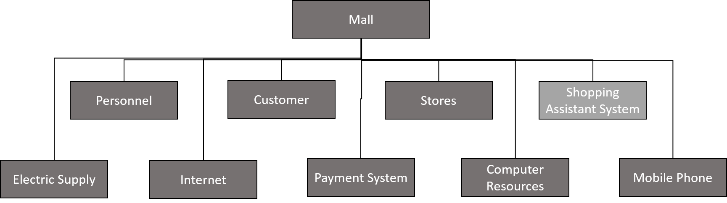

The electric supply, Internet, payment system and computer resources are the base systems that our own developed shopping assistant system will use. Mobile phone is personal device that usually could be used to search the information of product and service, even perform the navigation in the mall through the available floor index.

Personnel are the staff in the mall who will give customers suggestion when they have questions about the store position, service availability and etc. They act like help desk where customers sometime can get translation service from.

Based on some of the foundation systems, the shopping assistant system we proposed will combine most of the other systems in one device to address the major requirements from International tourists who will do shopping in the mall. And the system consists of major subsystems listed as bellows

* Information system
* Payment system
* Software application
* Equipment (robotic cart and tablet)
* Hardware system
* Recharge system

**Information system**

Information system is a subsystem in shopping assistant system. It consists of computer resources and mainly provides the capability of responding the requirement of information search. It may have a database for storing and updating the information of product, service and facility and other aspects which are useful to the end-users.

**Payment system**

Payment system will provide easy payment methods for end-users based on the existing technologies and systems such as credit card, mobile pay an etc. There may be some design works in the payment system specifically for the shopping assistant system, for example, it has to deal with the foreign card as well as currency. The goal of these works is to provide a seamless experience to end-users that make them feel like paying in their own country.

**Equipment (robotic cart and tablet)**

The shopping assistant device (robotic cart and tablet) are the main tool end-users will use in their shopping. The device is the main entry of the services. End-user will use this device to search information, navigate themselves in the mall, translate the speaking in and out, as well as carry their bags. During the operation, the device will work with other systems to perform the tasks that will address the requirements from end-users.

To meet different requirement from end-users, the shopping assistant device will be designed and developed as detachable parts, with one of a light-weight controllers and the other is payload carrier. the light-weight controller could connect to the payload carrier and track and control the payload, and the controller will be used along as it will provide most of the requirement from end-user, such as it could be used to search information, it could be used for navigation, and it could be used as language translation device. The payload carrier is only used to carrying bags. In case end-users want to use all the services, they could pay for using the controller and the payload carrier. For other cases, the controller could be used only.

With the controller, end-users could interact with the system to do information search, navigation and language translation. Thus, the system should install with interaction system which will control the sub software system like the payload carrier control system and services system for searching, navigation, and translation. The searching, navigation and translation will use the data coming from information system.

**Software application**

The software application is the main interacting system that customer will use in their shopping, it will contain a main interaction system that customer will use navigation service, translation service and information searching service.

**Hardware system**

Hardware system are subsystems that support the functionalities that the device provide to end-users. This system consists of WIFI and Bluetooth for connecting devices for the information transmission, as well as devices for security concerns. This system only covers the hardware devices used in the mall and usually are fixed devices.

**Recharge system**

Maintenance system is for daily use, for example the electric charge system which will be used for recharging the equipment of shopping assistant system.

Maintenance system also include people who will do the cleaning or redistribution that will make the system fully functioning every day.

### 5.1.2 Function flow diagram

Below chart is the high-level function flow of the shopping assistance system used in daily operation.

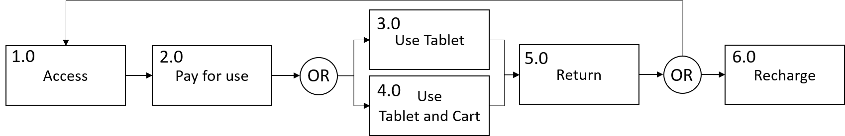

The high-level function flow will start from access, and customer need to pay for use either tablet or table and robotic cart. When they finish the shopping, they could return the robotic cart and tablet, which will be ready for next customer use or return to the recharge center if the battery is lower than certain level.

**The lower level function flow in interact is**

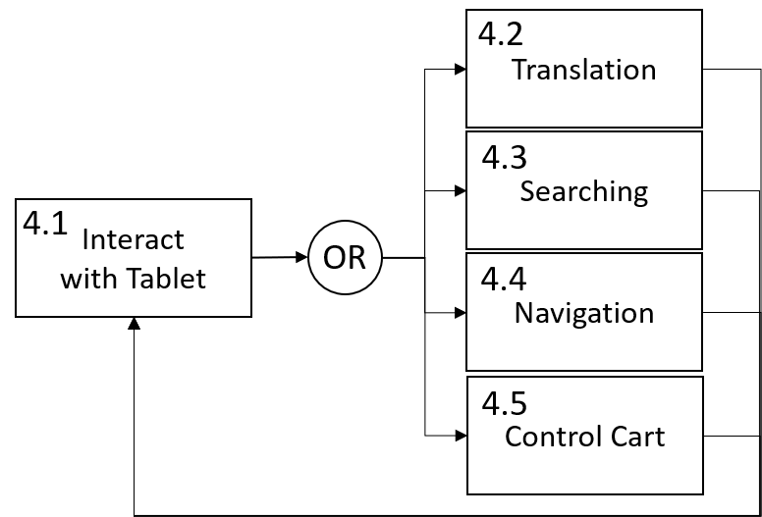

During operation the robotic cart and tablet, customer will interact with the software application to use either translation, information searching, navigation or controlling the robotic cart.

**The lower level function flow in navigation is**

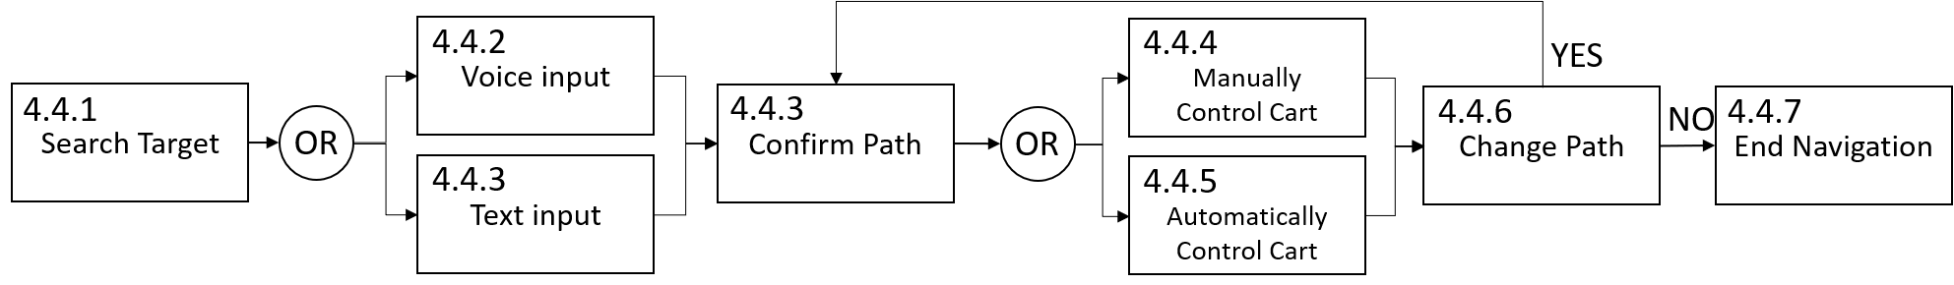

In navigation, customer needs to interact with the controller by input the name of the spot they want to go either with voice input or text input the system will be searching the database and find the information of target spot, then give a path planning with the information. Once the end-user confirmed the path. The system will drive the payload carrier if it is used in autonomous control mode or manually control the cart. The system will display the direction and guide the customer to the target spot. during the whole navigation, the system will receive the updated information from information system and the status of the controller itself for updating the path planning and estimating the remaining time and distance from the current spot of customer to the target spot, so that customer could get the latest information of the system for make decision further. Customer could choose the updated path or not, then continue the navigation until he/she arrives the target spot.

## 5.2 SOS configuration

Below figure is the SOS configuration of shopping assistant system.

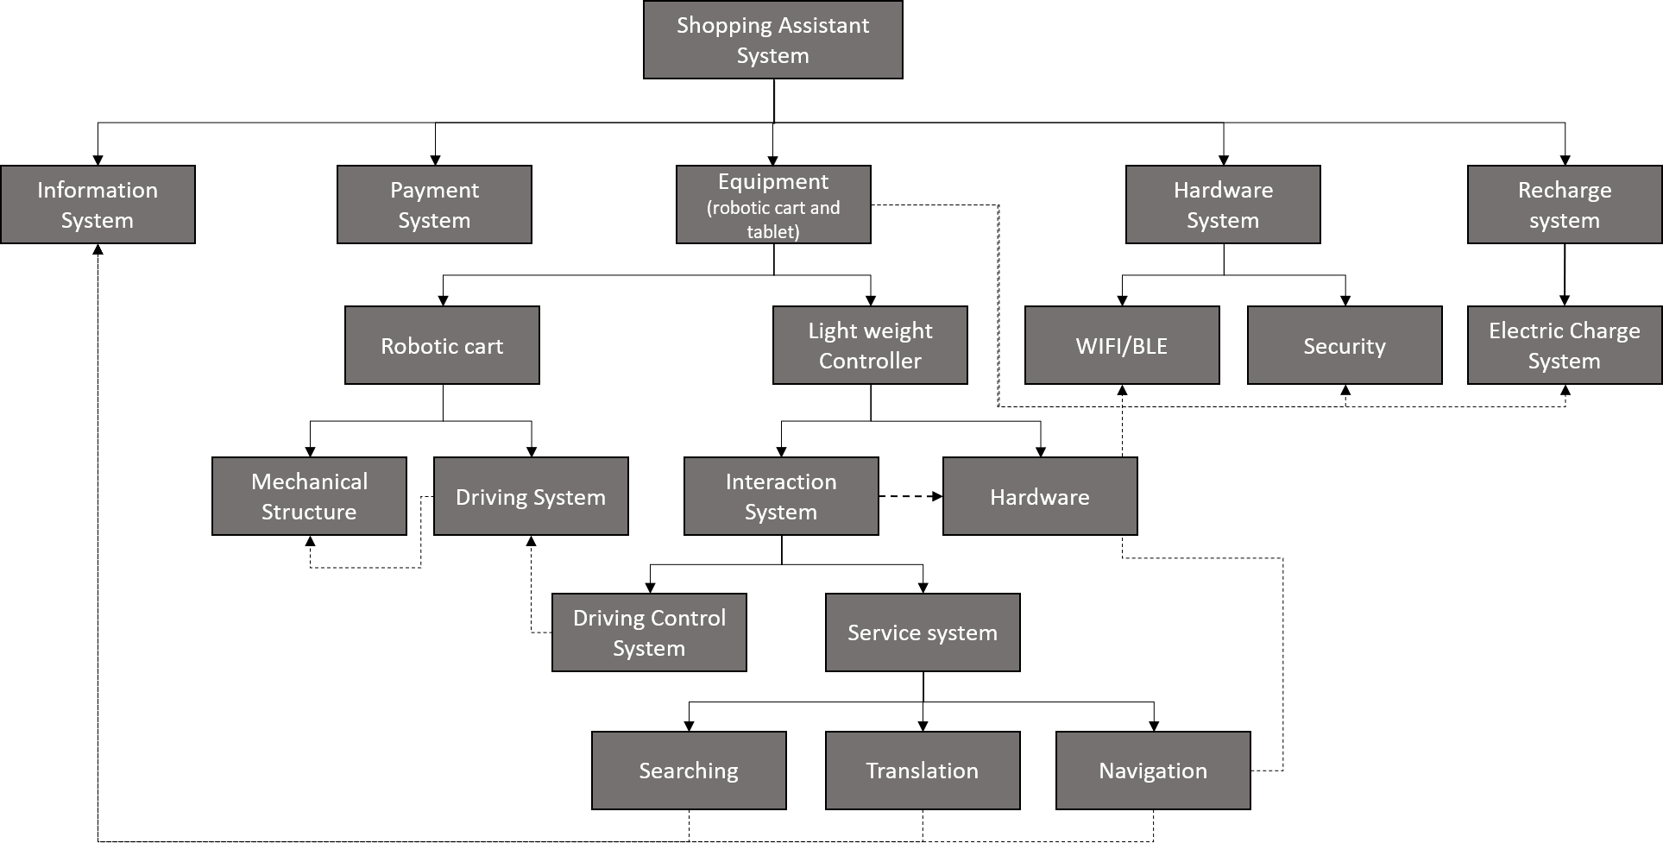

### 5.2.1 Operational Requirements of the SoS

The operational requirements of the various sub-systems of the SoS are given below:

**Information System**

* This shopping assistant device shall provide information system that transmits information from database to service system.

**Equipment**

* The battery and cable shall be installed to guarantee the power of the shopping assistant device and the device shall be low energy cost.
* This shopping assistant device shall be light-weight for end-users to maneuver when switch to hand operating and installed wheels to move easily.
* This device shall be able to carry customer’s bags if they choose the mode.
* This system shall provide correct location positioning and the navigation to end-users.
* Information search functionalities for end-users is also shall be enrolled to find where to buy the products/services they want.
* This device shall provide Chinese to English, Chinese to Japanese, Chinese to Korean, and Chinese to French translation.
* This shall use speaker/sound interaction method to give information and recommendation to end-users.
* Bluetooth monitor and other hardware are needed in the shopping assistant device to support the functions the system needs.

**Software application**

* The software application shall be used by customer to achieve navigation, translation and information searching.

**Payment system**

* Convenient payment way should be supported using credit card and easy to renew for end-users to continue using.

**Hardware system**

* The system should be able to transmit the data to tablet for achieving the navigation

**Recharge system**

* The recharge system shall be used for the battery of robotic cart recharge.

### 5.2.2 Maintenance Concept for the SoS

The maintenance concepts for the various sub-systems of the SoS are:

**Information System**

* The shopping assistant device may sometimes have some problems in transmitting information between service system and information system, like navigation errors, language translation mistake and information searching problems. It needs the repair and update of the data in the information system.

**Equipment**

* If the problem is about loss of signal or anything minor in software of device, the employee in mall who get the training about the shopping assistant before could repair it.
* However, if the problem is any more serious like the mechanical structure issues, it needs to send device back to our company and let our design team to repair it.

**Software application**

* There might be some bugs in the software application, if it is failed to be used, the bugs should be reported to software vendor immediately. And the bugs shall be fixed soon.

**Hardware System**

* If the Bluetooth is broken or any other connection problems that make the facility does not function according to the design including navigation, translation and driving, it can be repaired by the design crew of our company.

**Payment system**

* If the payment system has problems that make end-users cannot achieve payment as easy as in their own country just using credit card, there must be some issues that need send back device to our team to repair.

**Recharge system**

* If a recharge system is disfunction, it will be transported to company YY for further inspection and isolating the faulty unit. The faulty unit shall be transported maintenance shop for repairing or replacing.

### 5.2.3 Significant Technical Performance Measures (TPMs)

**Information system** - The system should transmit information between service system and information system in reasonable timeframe. The main technical performance measures are, the mean time of response which means the time between customer input and get the information back.

**Payment system** - The device provides end-user very easy and convenient way to pay to use just like they pay in their own country using credit card or other easy method.

The key technical measurement is the how many payment methods will be supported in the system.

**Equipment** Robotic cart and tablet

Robotic cart weight and size will be the key technical performance measure to ensure the equipment is cost effectiveness and easy to maneuver. Besides the speed of robotic cart in autonomously move will be the key technical performance measure.

**Software Application**

* Information transmit is exact and provide the products/services the customers want including information searching and accurate navigation. Mean time of response will be tested for making sure that customer will have an efficient interaction
* It provides Chinese to English, Chinese to Japanese, Chinese to Korean, and Chinese to French translation. Mean time of response and accuracy of translation will be the key technical performance measures.
* In navigation and information searching, the mean time of response and accuracy of information will be the key technical measures.

**Recharge system** – the time for fully recharging the robotic cart and the amount of electric use monthly will be the key technical performance measure.

## 5.3 Functional Interfaces of SOS

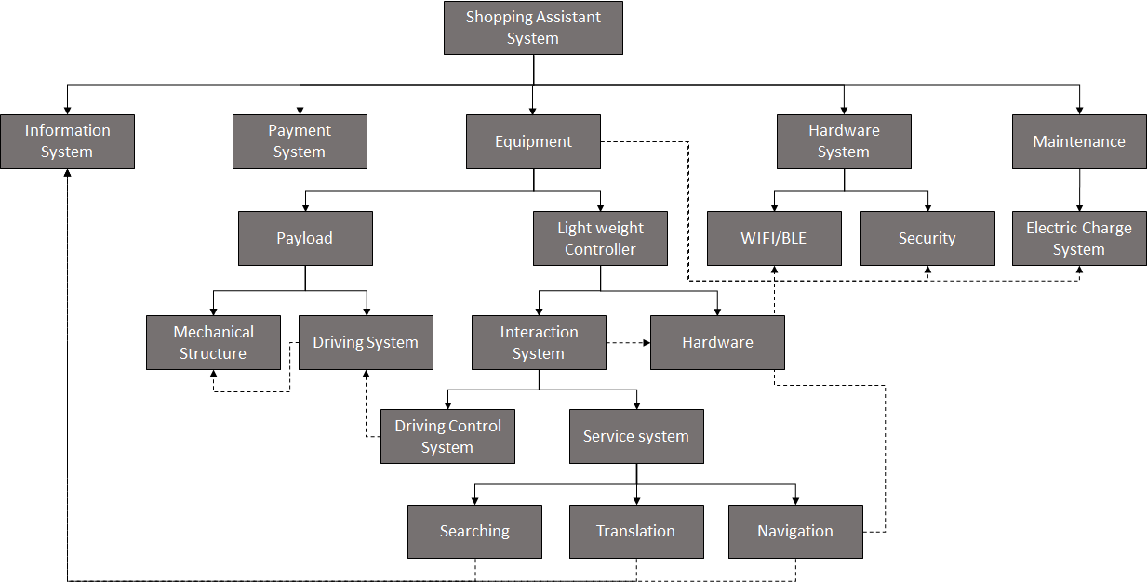

* Interface of electric charge between equipment and electric charge system.
* Interface of data exchange between controller and hardware system (WIFI, BLE, security).
* Interface of information transmit between service system and the information service (database).
* Interface of the maneuverability between controller and the driving system in the payload.
* Interface of controlling mechanical structure by the driving system.
* Interface of sending command from driving control system on controller to driving system of payload carrier.

# 6. Customer, System and Design requirements, and RAS with traceability

## 6.1 Customer Requirements

|  |  |
| --- | --- |
| ID | Requirement |
| CR1 | The system shall be easy for international end-users to interacted with. |
| CR2 | The system shall be easy to maneuver in the mall. |
| CR3 | The system shall be able to carry shopping bags. |
| CR4 | The system shall provide capability of searching availability, price and user comments of products and services. |
| CR5 | The system shall provide capability of navigation. |
| CR6 | The system shall be cheap to use. |
| CR7 | The system shall be able to be used for single purporse. |

## 6.2 System Requirements

|  |  |
| --- | --- |
| ID | Requirement |
| SR1 | The system shall provide language service for interaction and translation. |
| SR2 | The system shall be able to accept voice input and text input. |
| SR3 | The system shall be easy to pay for use and easy to return. |
| SR4 | The system shall be able be controlled autonomouly and mannually. |
| SR5 | The system shall be lightweight and in appropriate small size. |
| SR6 | The system shall provide space to place certain amount weight shopping bags. |
| SR7 | The system shall provide an application for end-users to search information of products and services in the mall. |
| SR8 | The system shall provide an application for navigating end-users to the store or spot where they want to go based on latest facility information. |
| SR9 | The system shall be able to operated at leaset 12 hours a day. |
| SR10 | The system shall provide detachable parts for different usages. |
| SR11 | The system shall be cost effective. |

## 6.3 Design Requirements

|  |  |
| --- | --- |
| ID | Requirement |
| DR1 | The system shall provide interaction with English, Chinese, German, Japanese and Korean. |
| DR2 | The system shall be able to translate English, German, Japanese and Korean to Chinese and Chinese to English, German, Japanese and Korean. |
| DR3 | The system shall be able to recognise voice input. |
| DR4 | The system shal be able to translate voice input to text. |
| DR5 | The system shall be able to accept text input. |
| DR6 | The system shall be able to accept credit card payment. |
| DR7 | The system shall be able to accept mobile payment. |
| DR8 | The system shall be able to be returned in any appropriate spot in the mall. |
| DR9 | The system shall be able to display remaining time for using. |
| DR10 | The system shall be able to track the end-user. |
| DR11 | The system shall be able to follow the end-user autonomouly. |
| DR12 | The system shall be able to switch between autonomous control and manually control. |
| DR13 | The system shall weigh no more than 8 pounds in total. |
| DR14 | The system size shall not exceed 10 inches width, 20 inches length and 30 inches height. |
| DR15 | The system payload shall be at least 20 kg. |
| DR16 | The system shall provide a database containing updated information of products, services and facility in the mall. |
| DR17 | The system shall provide a product/service search applicaiton. |
| DR18 | The system shall provide a searching application that will give a recommendation based on end-users’ search cretrias. |
| DR19 | The system shall provide an indoor navigation application. |
| DR20 | The system shall provide a long-hour battery to support 12 hours operation. |
| DR21 | The system shall consist of payload system a detachable system for other service. |
| DR22 | The system total cost should not exceed 1000$/per device |

## 6.4 Requirements Allocation Sheet

|  |  |  |
| --- | --- | --- |
| ID | Requirement | Method |
| SR1 | The system shall provide language service for interaction and translation. | Test, Demostration |
| SR2 | The system shall be able to accept voice input and text input. | Test, Demostration |
| SR3 | The system shall be easy to pay for use and easy to return. | Test,  Demostration |
| SR4 | The system shall be able be controlled autonomouly and mannually. | Demostration |
| SR5 | The system shall be lightweight and in appropriate small size. | Analysis |
| SR6 | The system shall provide space to place certain amount weight shopping bags. | Test |
| SR7 | The system shall provide an application for end-users to search information of products and services in the mall. | Test,  Demostration |
| SR8 | The system shall provide an application for navigating end-users to the store or spot where they want to go based on latest facility information. | Test,  Demostration |
| SR9 | The system shall be able to operated at leaset 12 hours a day. | Test,  Analysis |
| SR10 | The system shall provide detachable parts for different usages. | Demostration |
| SR11 | The system shall be cost effective. | Analysis |

## 6.5 Requirement Flow-Down Verification and Integration

|  |  |  |  |
| --- | --- | --- | --- |
| ID | Requirement | Requirement Verification | Function |
| SR1 | The system shall provide language service for interaction and translation. | VR1 - It shall be verified by testing that the system has language translation services | Design,  Operation  and Quality Assurance |
| SR2 | The system shall be able to accept voice input and text input. | VR2- It shall be verified by testing that the system is able to support voice input and text input | Design,  Operation  and Quality Assurance |
| SR3 | The system shall be easy to pay for use and easy to return. | VR3 - It shall be verified by testing that the system could accept multiple payment methods and to start use and return at any spot in the mall. | Design,  Operation  and Quality Assurance |
| SR4 | The system shall be able be controlled autonomouly and mannually. | VR4 - It shall be verified by testing that the system support manually control and autonomously control and could easily switch from one to another mode. | Design and Operation |
| SR5 | The system shall be lightweight and in appropriate small size. | VR5 - It shall be verified by inspection that the system is in appropriate weight and size. | Design and  Manufacturing |
| SR6 | The system shall provide space to place certain amount weight shopping bags. | VR6 - It shall be verified by inspection that the system is able to support certain amount of weight. | Design,  Manufacturing and Quality Assurance |
| SR7 | The system shall provide an application for end-users to search information of products and services in the mall. | VR7 - It shall be verified by testing that the system contains the software application for searching information. | Design, Operation and Qaulity Assurance |
| SR8 | The system shall provide an application for navigating end-users to the store or spot where they want to go based on latest facility information. | VR8 - It shall be verified by testing that the system contains software application for navigation. | Design, Operation and Quality Assurance |
| SR9 | The system shall be able to operated at leaset 12 hours a day. | VR9 - It shall be verified by inspection and testing that the system can be operated continuously for at least 12 hours. | Design, Manufacturing,  Operation and Quality Assurance |
| SR10 | The system shall provide detachable parts for different usages. | VR10 - It shall be verified by inspection and testing that the system contains detachable parts and each part works as expected. | Design, Maufacturing,  Operation and Quality Assurance |
| SR11 | The system shall be cost effective. | VR11 - It shall be verified by analysis that the system are running at a low cost. | Design, Operation |

## 6.6 Requirement Traceability

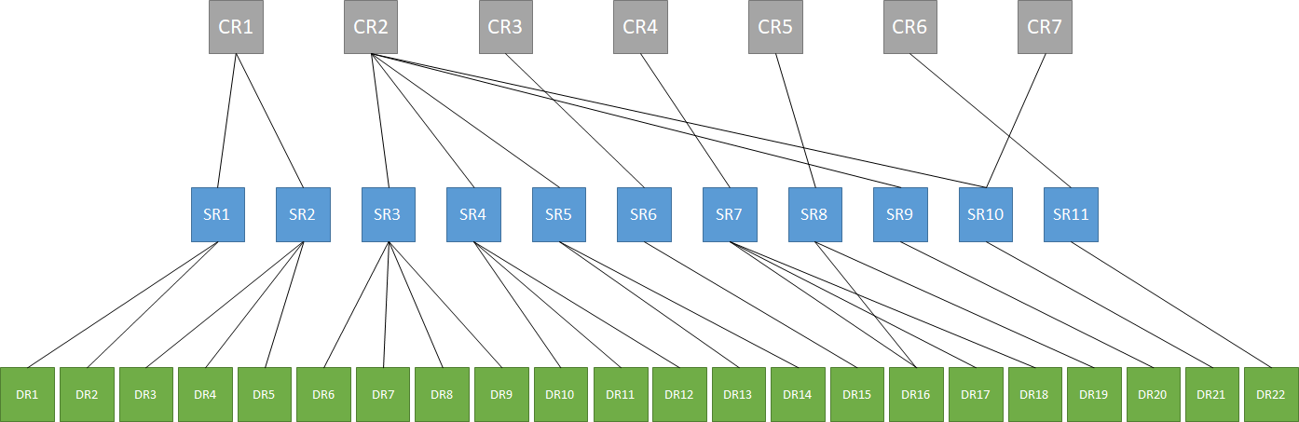

Requirement Traceability Matrix

|  |  |  |
| --- | --- | --- |
| Customer Requirement | System Requirement | Design Requirement |
| CR1 | SR1 | DR1, DR2 |
| CR1 | SR2 | DR3, DR4, DR5 |
| CR2 | SR3 | DR6, DR7, DR8, DR9 |
| CR2 | SR4 | DR10, DR11, DR12 |
| CR2 | SR5 | DR13, DR14 |
| CR3 | SR6 | DR15 |
| CR4 | SR7 | DR16, DR17, DR18 |
| CR5 | SR8 | DR16, DR19 |
| CR2 | SR9 | DR20 |
| CR2, CR7 | SR10 | DR21 |
| CR6 | SR11 | DR22 |

# 7. Reference

* <https://www.cabotsolutions.com/2018/02/ble-vs-wi-fi-which-is-better-for-iot-product-development>
* <http://energyusecalculator.com/electricity_wifirouter.htm>
* <https://batteryuniversity.com/learn/archive/whats_the_best_battery>
* <https://www.link-labs.com/blog/types-of-wireless-technology><https://www.airfinder.com/blog/rtls-use-cases/ble-vs-rfid-how-to-select-asset-location-technology>
* <https://www.airfinder.com/blog/rtls-technologies/rfid-vs-wifi-comparing-technology-and-cost>

**Milestone II - Prepare (part 2 of) a (3-part) report that includes the following:**

1. Title page (updated from Milestone M1) with:
   1. Original project name
   2. Team number ***and*** names of all team members
   3. Brief description of the project (just 3 sentences)
2. System operational and maintenance functional flows:
   1. Operational functional flow block diagram for the system (figures / diagrams with explanation)
      1. Develop operational functional flow block diagrams (FFBDs) to the third level. (Refer to Sections 3.7, 4.3, and Appendix A.)
   2. Maintenance functional flow block diagram for the system (figures / diagrams with explanation)
      1. Select one of the functional blocks and develop maintenance functional flows to the second level, to show how the maintenance functional flow diagrams evolve from the operational flows. (Refer to Sections 3.7, 4.3, and Appendix A.)
3. Technical Performance Measures:
   1. System requirements allocation diagram (figures / diagrams with explanation)
      1. For your own system, develop a figure – and associated explanation of why you chose the TPMs that you did and why they are important – similar to Figure 4.6 (page 109).
         1. Determine the top-level TPMs.
         2. Assign some top-level TPMs.
         3. Allocate these requirements as appropriate to the second and third levels.
4. Modeling and analysis of the system:
   1. Choice of analytical model(s):
      1. Develop the criteria that you would apply in selecting the most appropriate tools (and analytical models) for your application. (Refer to Section 4.6.2 and Figure 4.12 for multiple model applications.)
         1. Assume that as design engineers, you are looking for some analytical models/tools to aid you in the *synthesis, analysis, and evaluation process*.
         2. Address the considerations identified in Section 4.6.2.
            1. Identify the appropriate design characteristics that must be incorporated in the ultimate configuration. (The model selected must be “sensitive” to these characteristics, and incorporate some of the features identified in the text.) Do this from:

the development of system operational requirements

the maintenance and support concept

the identification and prioritization of TPMs

* + - * 1. Note that the requirements may dictate the utilization of several different models, applied on an integrated basis.
  1. Validation of analytical model:
     1. Explain how you would validate that a selected analytical model is adequate for your specific application. (Refer to Sections 4.6.2, parts of Sections 6.1-6.3, and Section 7.2.)
        1. Assume that you have selected an analytical model (pick one for your baseline, as per the above).
        2. **Hint:** One way to “validate” the model for its application is to select a known (already existing) design configuration and to utilize the model in assessing the characteristics of this known entity.
           1. Through an assessment and the implementation of a sensitivity analysis, one can gain some degree of confidence as to the model’s capability relative to its application in a new system design effort.
  2. Choice of CAD, CAM, CAS tools:
     1. Describe how the application of CAD tools can facilitate the system design process. (Refer to Sections 4.6.1 and 5.4. Also, parts of Sections 6.1-6.2.)
        1. Remember to identify the benefits you gain.
           1. **Hint:** In the utilization of CAD, one can graphically simulate the design of a total system, or any part thereof, through the presentation of three-dimensional models, graphic displays, different views of various specific design features, and so on.
        2. Remember to address some of the problems you may encounter in the event of misapplication.
     2. Describe how the application of CAM tools can facilitate the system design process. (Refer to Sections 4.6.1 and 5.4. Also, parts of Sections 6.1-6.2.)
        1. Remember to identify the benefits you gain.
           1. **Hint:** In the utilization of CAM and CAS, it is the same as for CAD, but as applied to the design of a manufacturing capability and the design of a logistics and maintenance support infrastructure, respectively.
        2. Remember to address some of the problems you may encounter in the event of misapplication.
     3. Describe how the application of CAS tools can facilitate the system design process. (Refer to Sections 4.6.1 and 5.4. Also, parts of Sections 6.1-6.2.)
        1. Remember to identify the benefits you gain.
        2. Remember to address some of the problems you may encounter in the event of misapplication.
           1. **Hint:** In selecting the proper tools, care must be taken to ensure that the tools are compatible and adaptable for the system being designed, are sensitive to the various system characteristics desired, and are compatible with each other in terms of interactions and interfaces. If these conditions are not met, then the design process will produce poor and inaccurate design data, resulting in many additional problems.
  3. Development of physical model:
     1. Answer the question: will you be developing a physical model of the system, or element thereof, early in the design process?
     2. Explain your answer and provide details. (Refer to Sections 5.4 and 7.2. Also, parts of Sections 6.1-6.3.)
        1. If used, include an explanation of what phase(s) of development the physical model(s) will be used in, which application(s) this(/these) model(s) will be used for, and the benefits of using such in those phases for your project.
        2. If not used, then the reasoning for why a physical model would not be useful early in the design process, in each early phase. (You must give reasoning as to when and why having a physical model would not be helpful.)
        3. **Hint:** “Physical” models (prototypes and mock–ups) are built and utilized to aid in the design evaluation process, and they help the designer to be able to visualize the current design configuration of the item being evaluated. They provide a better “replica” of the item being evaluated than one can see through a computerized database.
        4. **Hint:** Mock–ups are developed primarily in the Preliminary System Design Phase when the design is relatively fluid and one needs an aid of some type in order to facilitate design evaluation. See Section 5.4 for details.

Milestone M2 (Grade)

1. Proj name (1), team number (1), member names (1), 3-sentence description from M1 (2) --> 1 (5pts) --> 5 (CORRECTED 2019-04-26)

2. Operational FFBDs to 3rd lvl (10), maintenance functional flows to 2nd lvlfrom 1 func.block (10) --> 2 (20pts) --> 19.4

3. Determine top level TPMs / explanation (10), assign+allocate req.s to 2nd & 3rd lvls (10) --> 3 (20pts) --> 19.75

4a. Criteria for selection of analytical models/tools (w/design characteristics) & discussion of models selected (10) --> 4a (10pts) --> 8.6

4b. How would validate a selected analyt. model (20) --> 4b (20pts) --> 13

4c. How application of CAD, CAM, CAS tools can facil. sys design process (benefits + probs if misappl.) (3 apps, 5pts ea) --> 4c (15pts) --> 14.25

4d. Developing a physical model early in design? Yes/no and why? (10) --> 4d (10pts) --> 10

-- --> HW total --> 89

-- --> Out of --> 100

-- --> Percent Grade --> 90 (CORRECTED 2019-04-26)

# 1. Project Description

This project proposes a shopping assistant system aiming to help international tourists achieve a better shopping experience in big malls like Super Brand Mall (SBM) Shanghai. A mobile system integrating with information service will be developed for assisting the international tourists to do shopping in big malls. Thus, the system will be able to provide convenience to international tourists by saving their time on searching the right information and physical energy of carrying shopping bags.

# 2. System operational and maintenance function flows

## 2.1 Operational functional flow block diagram for the system

### 2.1.1 First level of operation functional flow

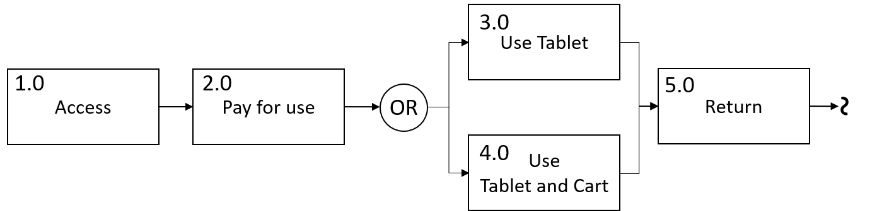

Figure 1: Operational functional flow block

**Access**

Sufficient amount of equipment shall be distributed in SBM Shanghai in order to give easy accessibility to users. In our plan, we will distribute 100~200 equipment including tablet computers and cart device at the major entries of the SBM shanghai. Considering some of the users will use tablet computer without the cart device, the ratio of amount of tablet computers to cart device is 1.5.

**Pay for use**

Users need to pay for using the equipment. Different payment methods will be provided to meet the various requirements from different users. The system shall provide methods of paying by mobile phone, credit card/debit card and cash. They could pay for use specific amount time, for example, half hour, 1 hour, 2 hours and 3 hours. Or they could pay for unlimited time until they return the equipment, but this payment only limited with using credit card.

**Use tablet**

Users could pay for only use the tablet computers, and the functions they will use will not include the cart device for carrying their bags. The tablet computer could be used for translation, searching product/service information and navigation.

**Use tablet and cart**

Users could pay for use both tablet computers and the cart device. The tablet computer will be used as a controller of the cart device. Thus, they are able to use the full functions provided by the system.

**Return**

Once users decide to end the journey, they shall be able to return the equipment easily. They could return the tablet computer at any exits/entries of the mall if they don’t use the cart device. Or they could attach the tablet computer on the cart device and leave the equipment at appropriate spot in the mall, they are not required to return the equipment at the exits/entries of the mall.

### 2.1.2 Interact with tablet computer flow block

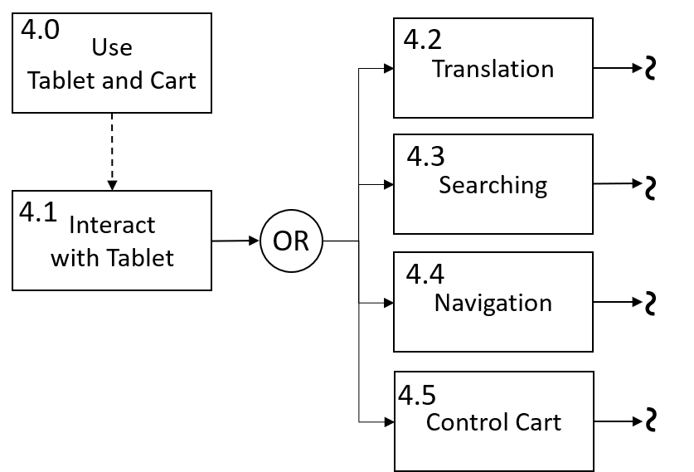

Figure 2: Interact with Tablet Computer

Once users start to use the table computer and the cart device, the first thing they need to do is set the language of interacting with tablet computer. The system will support major languages such as English, Chinese, French, Japanese, Korean. Then users could choose to use either the translation service, information searching service or navigation service. They could use the tablet to control cart device by turning on the automatic control or turning off the automatic control in order to manually control the cart device.

**Translation**

Translation service will provide service of translating product information, location information to the language they preferred. For example, when users need to know the items in the food menu, they only need to shoot the menu with the camera on the tablet computer. Or if they want to know what the clerk says, they could use the tablet computer to record the content and the translation service will translate the content to either text which will be displayed on the screen of the tablet computer or voice through the speaker on the tablet computer.

**Searching**

The information searching service is a fast way to obtain the information of product and service in the mall if the users do not know what product and service stores provide. The typical scenario is that when users want to buy a product but do not know which store has the product. They could use the searching service by simply typing the product or using voice input, all the products information including stores which have the product and price will be displayed on screen. Another scenario is if they want to try local food but don’t know which one is good. The searching service will tell them all the local food options and the comments from other users.

**Navigation**

Navigation is the typical application used in current daily life, and in big mall like SBM shanghai, it is also useful to users who have tight schedule and don’t want waste time on searching the location of the store. Once they decided which store they want to go, they could use the navigation service to find the position of the store in the mall, and the navigation service will plan a shortest path for them. They just need to follow the path displayed on the tablet screen, just like using google map navigation.

**Control Cart**

If users choose cart device to carry their shopping bags, they could use the tablet computer to control the cart device in automatic mode or manually control the cart device by moving the device around in the mall. The manually control is designed for difficult situations, such as when users want to go upstairs through elevators or in the narrow space where it is difficult for cart device to perform automatically move. By turning on the automatically control, the device will flow the users who carry the tablet computer as the cart device will keep a certain distance with the tablet computer by design.

### 2.1.3 Navigation service function flow block

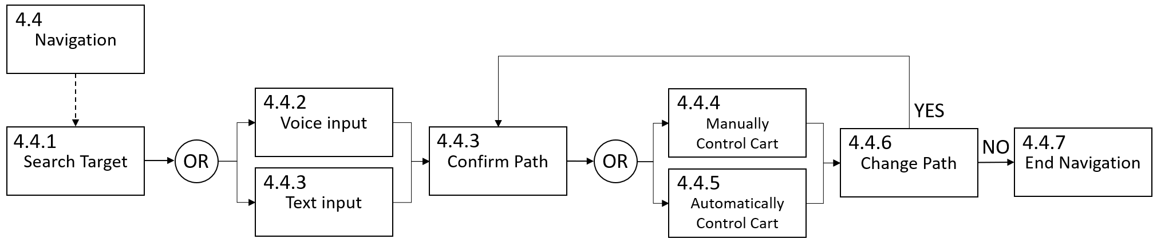

Figure 3: Navigation function flow block

The function flow of navigation starts from enabling navigation service, then users are required to search the target location in the mall either by voice input or text input. The service will display 1 or 2 paths on the tablet screen for the users depending on the traffic situation of the mall. Once users confirm the path, the navigation starts, users just need to flow the path indicated by the navigation service, and they could reach the destination. By controlling the cart device, they could choose automatically control mode or manually move the cart device. Due to the dynamic situation in the mall, the navigation service may update the path according to the position of users and the distance to the destination. User could choose to change the path or stay with the path they preferred at the beginning. Once users arrive the destination, the navigation service will end.

## 2.2 Maintenance functional flow block diagram for the system

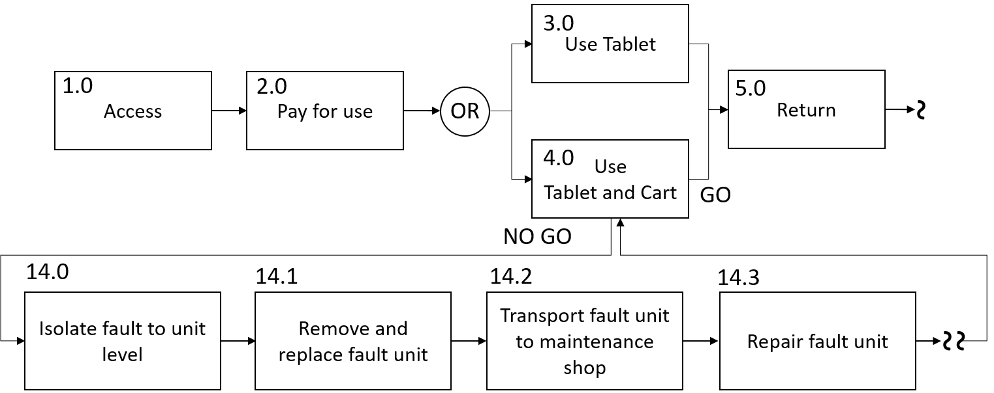

During using the table computer and the cart device, there will be a possibility that the equipment is dis-functional. Then the issue will be reported to maintenance and support team. The maintenance team will inspect the equipment and isolate the fault to unit level. For example, if the battery is died, they will remove the battery and replace a new functional battery and transport the dis-functional battery to the maintenance shop and repair the battery. The same process will be applied to other units of the equipment if the units are dis-functional.

# 3. Technical performance measures

## 3.1 System requirements allocation diagram

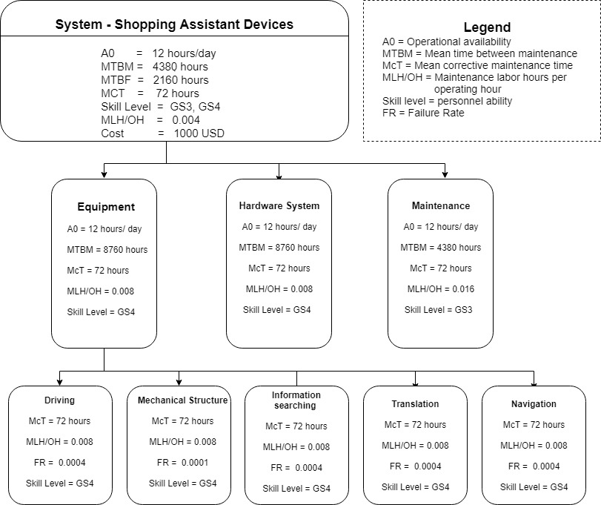

### 3.1.1 Determine the top-level TPMs.

The top level of the system is defined in Level 1 in figure above. The criteria for the shopping assistant device to be considered are:

* The reliability MTBF: 2160 hours
* Maintainability MTBM: 4380 hours
* A0: 12 hour/day
* Information search & process time: 2s
* Cart (device) size: 10 inch * 20 inch* 30 inch
* Cart (device) weight: 8 pounds
* Cart moving velocity: 0.5m/s to 2m/s
* Cart payload: 20kg at least
* Cost: below 1000$/ea

### 3.1.2 Assign some top-level TPMs.

* The reliability MTBF - 2160 hours as it will guarantee 6 months’ fully- functional use.
* Maintainability MTBM - The lifespan of the device is approximately 2 years and MTBM will be 1 years which means 4380 hours as it works 12 hour/day.
* A0: 12 hour/day - To guarantee the satisfaction of the customers’ shopping experience, the shopping assistant device is available for operation as fully-functioning for at least 12 hours for one time’s charging as the big mall usually open from 9:30 am to 9:30 pm every day. It is very important because fully-functioning operation must be guaranteed to provide all the services customers may need to use.
* Information search & process time: 2s - To guarantee the requirement device saving time for customers, the information search & process time of device will be less than 2 seconds using WIFI.
* Cart (device) size: 10 inch * 20 inch* 30 inch
* Cart (device) weight: 8 pounds
* Cart moving velocity: 0.5m/s to 2m/s
  + The device will be small and light-weight enough within 10 inch * 20 inch* 30 inch and 8 pounds to move easily and conveniently and the moving velocity will range from 0.5m/s to 2m/s to guarantee safety. Because the device could not move much slower or faster than normal walking speed pf a person to guarantee both the requirements of saving time and safety as it may knock people when moving too fast.
* Cart payload: 20kg at least - To carry bags maximumly for customers, the payload will be 20kg at most. It is important to have large and suitable payload to satisfy the huge need of shopping.
* Cost: below 1000$/ea - Each device will cost below 1000$ totally to control the cost within the acceptable range to guarantee the benefits of our company and the continuous improvement of the products.

### 3.1.3 Allocate these requirements as appropriate to the second and third levels.

* The whole system can be divided into 3 parts based on the second level of the operational flow.
  + Equipment – Equipment is mainly divided into cart device and light-weight tablet computer. The performance measure of equipment is dependent on its fully-functional using condition which depends on the mechanical structure, interaction system and hardware. And the lifespan of battery within the system should be 3-4 years normally using. The expected lifespan of these equipment should be 5 years which is its operational availability and should be undergo scheduled maintenance every 2 years in its life cycle for which it has a McT for 3 days which gives it the MLH/OH of 0.008. So, it has a MTBM of 2 years and the skill level for this work is usually GS4 or higher.
  + Hardware system - Since the use of Hardware system mainly in WIF/BLE and security, it has a higher operation period between 2-4 years and has 3 days McT. Then MLH/OH is range from 0.004 to 0.008. The hardware system has the MTBM of 2 years usually. Skill Level required is GS4.
  + Maintenance - The major performance parameters of the maintenance will be the electric charge system. The system should be maintenance once a year and the McT is 3 days per maintenance which gives a MLH/OH of 0.016 and MTBM is 1 year (4380 hours). Skill level required is GS3.
* Based on Level III of the operational flow, the equipment of shopping assistant device can be classified as follows:
  + Driving – The driving system which driving the device automatically following the end-users.
  + Mechanical structure - The physical design of the device including the payload and driving controller.
  + Information searching – This belongs to interaction system which need big database and reasonable time response within 2 seconds.
  + Translation – This includes the multiple languages translation such as Chinese to English, Chinese to Japanese, Chinese to Korean, and Chinese to French translation and vice visa. Also, the system can provide voice translation as well as text translation on the screen. To improve the satisfaction of customers, it will also provide translation service through scanning the text and translating shown on the screen.
  + Navigation – This includes navigation indoor which provides both the voice navigation and map on the moveable device’s screen between two spots.

# 4. Modeling and analysis of the system

## 4.1 Choice of analytic models

### 4.1.1 Develop the criteria

As design engineers, we have to develop the criteria that will be aid in selecting most appropriate computer-based tools and analytical models to analyze the system and verify the various system requirements. These analytical models/tools should be able to help us in the synthesis, analysis, and evaluation of the system that we are designing and the model we create must be adapted to the problem at hand and the output must be oriented to the selected evaluation criteria. The extensiveness of the model will depend on the nature of the problem, the number of variables, input parameter relationships, number of alternatives being evaluated, and the complexity of operation.

### 4.1.2 Address the considerations

1. the development of system operational requirements - This includes the reasonable response time, size and weight of cart device, system input (critical parameter) and the lifespan of the system.
2. the maintenance and support concept - This includes the daily maintenance activity on the electric charge system to provide enough power of the device which could support 12 hours’ fully-functional use after one-time charging.
3. the identification and prioritization of TPMs - These are the system specific parameters which aid in deciding the prioritization of TPMs of the system where we choose the interaction system model as the most important one in our project as it impact most here.

For our shopping assistant devices project, the system here contains serval modules and due to its complexity, the criterions are established according to the nominal models that can be used for the system.

Take the robotic design as an example, we will use CAD system to create a digital design for presenting the outlook and material of the robotic cart.

We will consider all the material of the cart device including the material covering the cart outside, the wheels leading the cart to build a lightweight cart with 8 pounds.

Should consider selecting the proper electric motor with right drive because:

1. It is essential to getting the performance which guarantee the velocity of 0.5 – 2m/s with 20kg payload condition to satisfy the customers’ requirements.
2. The capacity of the motor to do work should approach the level which satisfies 12 hours’ driving of device which require the enough horsepower.

Should consider the selecting of capacity of battery that can provide 12 hours’ fully-functional use after one-time charging for every time maintenance.

Should consider the cost of all the materials selected range from a accepting price to limit the total value below 1000 USD.

Should consider the size of the cart device including the width, length, height and the size of all wheels to make the whole cart device range within 10 inch * 20 inch * 30 inch.

Combine all the requirements of the robotic cart, the created CAD design will be able to show the weight and size of the robotic cart and the mass gravity and other related property could be evaluated before manufacturing.

## 4.2 Validation of analytic models

Take CAD model of robotic cart as an example, to validate the CAD design of robotic cart in terms of material cost-effectiveness, we will use CAE with giving the appropriate force to simulate the stress distribution, hence we will find if there are some part of the robotic cart could be cut material off.

And the size and weight could be evaluated in the CAD system, that will be easy to validate if the design is expected or not.

With apply dynamics, we could simulate the velocity of the robotic cart under different payload situations.

## 4.3 Choice of CAD, CAM and CAS tools

The major part of the system is the equipment that end-user will interact with during their shopping in the mall. The equipment consists of a lightweight tablet computer, a cart device and the software applications embedded in the tablet computer for supporting the services like translation, searching and navigation.

Using CAD, CAM and CAS tools could help us design the physical equipment that meets the criteria in an efficient way and illustrate the data flow in the design phrase therefore to help us to design the efficient flow of data among the system.

### 4.3.1 CAD tools for modeling the physical equipment

In order to design a light weight and appropriate shape of the cart device, we will leverage the CAD software such as Autodesk Inventor, Solidworks to design the 3D model for each part the cart device. By applying the specific configuration of the size, we are able to find the configuration of size and position in the cart device for other components, like wheels, actuators, and the platform of payload. So that we are able to select appropriate existing components in the market.

The CAD tools will also used to design a user-friendly cart device by considering the practical, fashionable shape of the cart device. As well as design the shape size of the tablet computer, in order to make it easy to be carried and attached to the cart device.

After each part of the equipment is designed with CAD software, we are able to assembly them together in the CAD software to see if every part is good or not to form a final equipment model. During this design process, we are able to address most of the problems in the equipment shape design and finally come up with a 3D presentation of the equipment with different views that can tells the details of shape of the equipment.

### 4.3.2 CAE tools for optimizing the weight and internal structure of the equipment

One we have a good shape design for each part of the equipment, we will use the CAE software to optimize the material as we are trying to design a lightweight cart device with maintain the stiffness with respect to the payload specification.

Giving the payload configuration and force may perform on the cart device, CAE tools can be used to determine the material of each part and simulate the typical scenario for using the cart and analyze the distribution of the applied force. Further we could reduce the material by redesigning the internal structure of each part of the cart device and make a material efficient design for the cart device.

### 4.3.3 CAM tools for prototyping the physical equipment

After we finish the initial design of the equipment, the CAM tools could be used to prototype the equipment, mainly focusing on the shape of the cart device. 3D printing and NC machining technologies will be leveraged in this phrase.

During prototyping, we could identify the parts that are difficult to fabricating or not material efficient. The prototyping with CAM tools could help us to learn the inefficient or bad design in the 3D model, therefore it will guide the redesign process so that we can address most of the problems in the manufacturing phrase before massive manufacturing.

With the prototype, we could assembly all the components into the equipment and build a functional prototype and test the whole equipment to validate our design for every part of the equipment.

With applying CAD, CAE and CAM tools, we could address most of the problems that may occur in the design process and therefore accelerate the design process and save the cost of design.

### 4.3.4 UML diagram for illustrating the information data flow

As the equipment will work with the hardware system and electrical system that distributed in the mall, and communicate with the information system, we could use UML diagram to illustrate the process of data interaction and communication, to understand the data flow among the system.

### 4.3.5 CAS tools for management of user behavior data and system data

CAS tools could be used to maintain the list of hardware devices, the electric charge system and the equipment. We will build a database to record and update the status of each hardware. This is the crucial part of maintenance and support. With this database, we could easily track each hardware device (BLE device and WIFI device), electrical charge system and the equipment (tablet computer and the cart device) during whole life cycle. That will make the maintenance work more straight forward, and also could help us to identify some problems in the system. For example, if we find some of the component does not work as expected or as their vendors promised, we might need to re-evaluate the component and replace with similar component from other vendors.

We will build another database for tracing the user’ behavior, such as the mean time of using the system, the frequency of using specific service, and the feedback of using the system. So that we can understand the real situation by analyzing the data coming from real users. This will help us to improve the design in future.

## 4.4 Development of physical model

In designing the system, a physical model for cart device will be developed. This physical model will be used to validate the design and test the full function with integrating other existing components.

A physical cart device will be developed in early design process by using 3D printing or NC machining.

The physical cart device is the one of key part of the equipment that end-user will interact with. Despite of the software system, the physical cart device will be used to validate the criteria of size and weight, validate the integration/assembly of the equipment, the interface of the electric charge system and the communication with the hardware system.

By using different material to build the cart device for prototype, and assembly all the components to the cart device, including the actuators, the electric systems and wheels, we are able to tell the exact size and weight of the whole equipment, as well as the real feeling of maneuvering the equipment, this is a crucial part of validation and will reveal some problems that we are unable to find in design with CAD tools.

We also need this physical prototype of cart device to validate the interface of electrical charge system, to see if the device is able to charge with the plug of the electric system. In addition, we could address some problems in design of the electric system as the whole system has to fit into the environment of the mall.

We will move the physical prototype of cart device around the mall to test the internet connection and data transmission efficiency between the equipment and the hardware system which is distributed at the fixed spot around the mall. With this test, we are able to reveal the problems in data transmission, hardware distribution and information system, therefore we are able to redesign and fix the problems in the early stage of design process instead of letting some potential problems skip to the stage of using by real end-users.

# 5. Reference

* Systems Engineering and Analysis (5th edition), Benjamin S. Blanchard, Wolter J. Fabrycky

**Milestone III- Prepare (part 3 of) a (3-part) report that includes the following:**

1. Title page (updated from Milestone M2) with:
   1. Original project name
   2. Team number ***and*** names of all team members
   3. Brief description of the project (just 3 sentences)
2. Evaluation during Project Phases:
   1. Explain how “evaluation” is accomplished in each of the phases shown (i.e. Blocks 0.6, 1.5, 2.3, 2.4, 3.4 and 4.4) in Figure 2.4. (Refer to Sections 6.2, 6.4, and 6.5, and Figure 2.4.)
      1. Note that the test and evaluation activity identified by block 0.6 is essentially accomplished under “Analytical Evaluation” in Figure 6.2 (page 153)
      2. Note that the test and evaluation activity identi­fied in block 1.5 is accomplished as “Type 1 Test” in Figure 6.2.
      3. Note that the test and evaluation activity identified in block 2.3 is accom­plished as “Type 2 Test” in Figure 6.2.
      4. Note that the test and evaluation activity identified in block 3.4 is accom­plished as “Type 3 Test” in Figure 6.2.
      5. Note that the test and evaluation activity identified in block 4.4 is accom­plished as “Type 4 Test” in Figure 6.2.
      6. Note that the accomplishment of the various tests is described in Section 6.5 (page 162).
3. System Test and Evaluation Plan:
   1. Develop a system test and evaluation plan (i.e. a TEMP, or equivalent). (Refer to Section 6.3. Note that each and every single one of the seven items should be included or addressed in the plan.)
4. Decision Situations:
   1. Identify a decision situation and indicate the variables under the control of the decision maker and those not directly under his or her control.
      1. An example of a decision situation is the establishment of an optimal procurement quantity for a single-item inventory. Here the evaluation measure is cost, and the objective is to choose a procurement quantity in the face of demand, procurement cost, and inventory holding cost, so that the total system cost is minimized. The decision variable under direct control of the decision maker is the procurement quantity.
   2. Identify a multi-criteria decision situation with which you have experience. Select the three to five most important criteria. (Refer to Section 7.4.1.)
   3. Formulate an evaluation matrix for a hypothetical decision situation. Then, formulate an evaluation vector for the above hypothetical decision situation under assumed certainty. (Refer to Sections 7.6.1 and 7.6.2.)
   4. Develop an example to illustrate the application of paired outcomes in decision making among a number of non-quantifiable alternatives. (Refer to Section 7.6.2.)
5. System Data Collection and Evaluation:
   1. Identify what data are required to measure the following for your system: cost effectiveness, system effectiveness, operational availability, life-cycle cost, reliability, and maintainability. (Refer to Figure 2.8, Section 6.5, and Figure 6.4.)
      1. *Cost–effectiveness* (which is reflected by “system value” in the figure) refers to the measure of a system in terms of its applicable technical factors (e.g., system effectiveness, operational availability, producibility, dependability, supportability, sustainability, and those applicable “technical” factors that relate to overall system “performance”) and total life–cycle cost. Thus, the data collected must enable the assessment of system performance (or the critical TPMs) and total cost.
      2. *System–effectiveness* is a function of system performance, availability, dependability, supportability, sustainability, and related technical factors. Thus, the data collected must enable an assessment of overall system performance, but not necessarily cost.
      3. *Operational availability (Ao)* is a function of system “uptime” and “downtime,” or MTBM and MDT, or the percentage of time that the system is “operational” when required. Thus, the data collected must enable the assessment of the system in terms of its mission, its time of operation, and any downtime that is expended in the accomplishment of mainte­nance.
      4. *Life–cycle cost (LCC)* includes all future costs associated with research and development, design, test and evaluation, production and/or construction, system utilization, maintenance and support, and system retirement, material recycling and disposal. Thus, the data collected must include ALL costs, cost projections and profiles, the appropriate reliability and maintainability data, logistics data, and so on.
      5. *Reliability* (*R, MTBF*)is a function of system operating time (or operating cycles), system failures and failure rates, the actual causes of failures, and so on. The data collected must cover system operations, system failures, and the requirements associated with the repair actions taken in response to failures. (Refer to Section 12.3.)
      6. *Maintainability (MTBM)* is discussed in Section 13.4.

Milestone M3 (Grade)

1. Proj name (1), team number (1), member names (1), 3-sentence description from M1 (2) --> 1 (5pts) --> 5

2. How is evaluation done in each of 5 phases shown in Fig 2.4? (Block 0.6/Analyt. Eval (2), Block 1.5/Type 1 Test (2), Block 2.3/Type 2 Test (10), Block 3.4/Type 3 Test (2), Block 4.4/Type 4 Test (2)) -- note that Block 2.4 listed in M2 is a typo --> 2 (18pts) --> 15.8

3. System Test & Eval Plan (TEMP or sim.) (7 items, 5pts ea) --> 3 (35pts) --> 32.75

4a. Decision situation with controllable + not-direct-contr. var.s (10) --> 4a (10pts) --> 9.25

4b. Multi-criteria decision situation with 3-5 most important criteria (15) --> 4b (15pts) --> 15

4c. Decision Eval. Matrix w/decision situation, eval.vector under assumed certainty --> 4c (5pts) --> 3.9

4d. Example of paired outcomes in decision making among # of non-quantifiable alt.s (10) --> 4d (10pts) --> 7.9

5. Data required to measure: cost-effectiveness, system effectiveness, operational availability, life-cycle cost, reliability, maintainability (6 to measure, 5pts ea) --> 5 (30pts) --> 20.5

-- --> HW total --> 110.1

-- --> Out of --> 128

-- --> Percent Grade --> 86.015625

# 

# 1. Project Description

This project proposes a shopping assistant system aiming to help international tourists achieve a better shopping experience in big malls like Super Brand Mall (SBM) Shanghai. A mobile system integrating with information service will be developed for assisting the international tourists to do shopping in big malls. Thus, the system will be able to provide convenience to international tourists by saving their time on searching the right information and physical energy of carrying shopping bags.

# 2. Evaluation during Project Phases

Evaluation is accomplished in each of the phases shown in table below:

|  |  |  |
| --- | --- | --- |
| **Phase** | **Evaluation Type** | **Evaluation** |
| Conceptual Design | System Level Evaluation   * Type 0 Testing | In our design of shopping assistant system, this phase is very important since we need to use the analytical model to get the device performance and the various top-level models needed to have simulation of the shopping car device are as follows:   1. 3-D model of the shopping cart (size, material, surface, weight) 2. Cart moving simulation (velocity, driving power and torque calculation) 3. Cart payload simulation 4. Information processing simulation (interaction time) 5. Total Cost |
| Preliminary Design | Subsystem Level Evaluation (Engineering Models)   * Type 1 Testing | The sub-system levels evaluation comprises of taking input from the results of system level analyses and applying those inputs to the sub-systems in the form of both tests and analysis.  For our design project: shopping assistant system, in this phase, the tests we should consider are:   1. Mock-up models of the shopping cart to see which design provides better lightweight and required size. 2. Test model for checking the cart velocity. 3. Material testing model to see the payload of cart. 4. Mock-up testing model for checking the interaction time of touchable screen. |
| Detail Design & Development | Component Level Evaluation (Prototype Models)   * Type 2 Testing | In this phase testing, it includes performance tests, environment qualification, structure tests, reliability qualification, maintainability demonstration, support equipment compatibility tests, personnel test and evaluation, technical data verification, software verification and supply chain element compatibility tests.  For our project, it corresponds to the testing to be conducted on actual hardware and software to meet the design equipment requirements:   1. Performance tests - Here the individual models are tested separately to ensure that each model is functioning as per design. We should test whether the diving controller and driver give the required output. 2. Structure tests – Materials here are to be used for the shopping cart body and surface and we need to check the size and weight to meet the requirements. We also need to test the material whether they can sustain damage when fall down. There are various materials considered and each are tested to yield the best fit material. 3. Reliability qualification – We need to test the lifecycle of our system’s equipment including the battery lifespan, touchable screen’s usability. 4. Maintainability demonstration – Mock models are used to demonstrate how maintenance can take place. 5. Personnel Test and Evaluation – Various level of personnel training, test and evaluation involved are people who will handle the cart device maintenance, people who will work in big market to ensure the cart device being the right place. 6. Technical data verification – the testing model should give the output of driver, information processing and cart payload. 7. Software Verification – Software testing at the touchable screen should be checked to see the proper functional using as the device can translation, information searching and navigation. 8. Security – In this case, our system need test to check the information security of end-users. |
| Production & Construction | Test and Evaluation (Production Models)   * Type 3 Testing | At this level, testing is conducted through a series of simulated operational exercises. This is basically a “practice test” to use a person who are trained operating our shopping assistant device and our design engineers will perform the tests. Various level of testing like the information processing time, cart moving velocity, cart payload and fully-functional using time are collected and examined by user and design engineers to look for anomalies in modeling, designing and so on. |
| Operational Use and System Support | Test and Evaluation (Operational Model)   * Type 4 Testing | During this phase, formal testing will be accomplished in conjunction with the incorporation of technology enhancements and system upgrades to ensure that the appropriate measures of effectiveness are being maintained as system operation continue.  Once our shopping assistant device is in operation, the performance like efficiency and fully-functional using condition will be assessed and the data & information will be collected and analyzed by the user and design engineer to evaluate actual performance versus expected performance. |

# 3. System Test and Evaluation Plan

The test report shall include at a minimum, photographs of the test set-up, any deviations and failure information, corrective actions if any, detailed data as required, test data sheets and

results. And test and evaluation plan should include：

## 3.1 Identification of all the tests to be accomplished, the items to be evaluated, the schedule of each, required inputs and expected outputs

Our tests shall be carried out on the component of our design system. These tests shall be conducted by software and hardware manufacturers which includes:

* Cart device performance test – in this category, the various sub-modules are integrated and tested for getting the whole cart device performance to see whether it meets the requirement. In our project, we need to simulate the cart device model and test the performance of cart device.
* Information processing test – information searching and showing up need searching, transferring time and it should be within 2 seconds which meet our requirement.
* Maintenance test – we should check the charging time of the cart device and whether the battery could support 8 hours’ fully-functional using of users.
* Security test – to ensure customers’ information safe, it is important to make the system information security as it involves end-users’ pay information and this aspect can be checked by using qualified personnel to try and hack the software system in different ways possible and test the ability of the software to resist such attacks.

## 3.2 Identification of the organization responsible for the administration

Since this project is created by our company, our company is responsible for providing a technical design of the shopping assistant device that meets all the user requirements and then these design specifications are sent to the manufactures who will provide the actual physical system and software providers. After the design phase, the shopping assistant cart will be sent to big shopping mall to test the product performance.

## 3.3 A description of the test location, local political factors and environment

* Test location - All these tests location should be company’s test facility and personal used will be trained technicians. After the test within company, it should be tested and evaluation within the big mall once the products be set and used by users. We also need to collect and analyze the information and data for future improvement.
* Local political factors/ social factors – Since our tests are all performed within our company facilities, and only trained personnel test it, there may not be serious social concerns and local political concerns.
* Logistics provisions – the major stress test is performed on the shopping assistant cart’s equipment, maintenance and hardware including hardware like WIFI/Bluetooth, battery and touchable screen. As the amount of our device is not huge, it may be no serious concerns about the logistics provision.
* Test environment – All the test environments for the shopping assistant device are indoor in the company with simulated conditions.

## 3.4 A description of the test preparation phase of each category of testing as required

In the section of TEMP, we list down the specifications of the various tests’ preparation:

* In every test, we need make documents with detailed instructions which have to be followed by the conducting personnel.
* The training of test and supporting personnel – in every test, some experienced are involve ensuring transfer knowledge and prevention of any technology error.

## 3.5 A description of the formal test phase

* Software requirements – Many tests require software control to perform the tests. The
  + particular software required and the expected input and output of the software are
  + documented in this part.
* Data collection - During the test and evaluation, we should record the information of each test’s output like the information processing time, total cost of device, size and weight of the shopping cart, MTBF and cart moving speed to get the average value for the whole testing models.
* Test reporting - Every test performed has to be documented in prescribed format.
* The test has to be described in detail and the expected and actual outputs are also
* documented in the TEMP for future references.

## 3.6 A plan and associated provisions for retesting

Retesting may happen because sometimes the tests performed may not yield expected results. This always does not mean that the models or designs are wrong and everything has to be re-worked. If the desired and actual outputs from a test are different, then we need to know three things and based on their answers necessary action are taken: why did the test fail? How was the test plan validated? And is there any different way that the test can be performed? Suppose the information processing time test failed as sometimes it use over 2 seconds, it does not mean the model is wrong, it may because the internet connection missing or WIFI problem that we can just change to a different place to test.

## 3.7 A description of the final test report

The entire test report based on all the tests and the test results are complied into the final report based on the format specified by the users which in this case the trained users and the report is handed over to the person that organized our design team in our company and give to big mall who has interest to get our shopping assistant device. Then we can get feedback from the big shopping mall and based on the feedback, corrective action can offer if needed.

# 4. Decision Situations

## 4.1 Decision evaluation with controllable and uncontrollable variables

Decision evaluation is an important part of systems engineering and analysis, Evaluation is needed as a basis for choosing among the alternatives that arise during the activities of system design, as well as optimizing systems already in operation. In either case, equivalence provides the common evaluation measure on which choice can be based.

Decision evaluation often requires a combination of both money flow modeling and economic optimization approaches. When investment cost, periodic costs, or project life is a function of one or more decision variables, it is important to optimize over these variables as a prerequisite to the determination of economic equivalence. This optimization is linked to a decision evaluation through one or more money flows, which, in turn, are used in calculating a measure of economic equivalence. Optimization requires that an evaluation measure be derived from an economic optimization model.

An economic optimization function is a mathematical model formally linking an evaluation measure, E, with controllable decision variables, X, and system parameters, Y, which cannot be directly controlled by the decision maker. It provides a means for testing decision variables in the presence of system parameters. This test is an indirect experiment performed mathematically, which results in an optimized value for E. The functional relationship, in its unconstrained form, may be expressed as

E = f (X, Y)

In our project, the cart device design is one of the equipment requires decision evaluation. Our decision is to choose a cost efficiency design which meet the operational requirement. The evaluation measure E in this case is the cost of each cart. The output of the evaluation function is to minimize the cost of the design.

The controllable variables X in this case are:

* Material to build the cart device.
* Total weight of the cart device.
* The size of the cart device.
* The payload of the cart device.

The system parameters Y which cannot be controlled by the decision makers are:

* Cost of the material used in the cart device.
* The total material wasted in the cart manufacturing.
* Labor rates, manufacturing and support costs.
* Material production and transportation cost.
* Turn-around time between design submission and actual production.

## 4.2 Multi-Criteria decision situation

In a real world, a decision must made in the face of multiple criteria that jointly influence the relative desirability of alternatives under consideration. The decision should be made only after considering all relevant criteria, recognizing that some are quantifiable, and others are only qualitative in nature.

In our project, one of the multi-criteria decision situations is to choose the indoor real-time location technology among the wireless network technologies. The objective is to select the best technology which cover most of the operational requirements and is cost efficiency. There are several factors that are involving in making this choice and the most important factors are listed as follows:

* Speed – as for tracing the cart device and tablet computer, the speed of data transmission needs to be evaluated. The real-time data transmission will be a important factor to the user experience.
* Accuracy – accuracy is an important factor of indoor location technology in terms of user experience. In order to give the best experience to the end-user, the accuracy of each technology will be evaluated.
* Transmission Range – as the user will do shopping in the mall which is a big place, the data transmission range of wireless connection technology should be evaluated, once the distance between cart device and tablet computer reaches the maximum of data transmission range, the system will be not robust. So we need to select the technology with appropriate data transmission range which will cover the most user scenarios.
* Power consumption – As the equipment carry a rechargeable battery and is required to be perform at least 12 hours per day, the power consumption of this indoor location should consume less power.
* Cost – as the cost varies in different option of adopting different technologies, we need to evaluate the each set of devices used in each cart and come up with a total cost for the technology we choose given by an estimated quantity of equipment we are going to distribute.

## 4.3 Evaluation matrix and Evaluation vector for a hypothetical design situation

A decision evaluation matrix is a formal way of exhibiting the interaction of a finite set of alternatives and a finite set of possible futures. The general decision evaluation matrix is a model depicting the positive and negative results that may occur for each alternative under each possible weight.

In our project, the selection of indoor location technology (wireless connection technology) has an important impact on the system mission parameters (in order to meet the operational requirement of tacking the cart device and tablet computer) and overall system configuration.

Given two alternatives in the market, Wi-Fi and BLE, the sample analysis is listed below.

* Alternatives
* Wi-Fi – Wi-Fi uses radio waves (RF) to allow two devices to communicate with

one another. The technology is most commonly used to connected Internet routes to devices like computers, tablets and phones; however, it can be used to connect together any two hardware components. Wi-Fi is a local wireless network that run of the 802.11 standards set forth by the Institute of Electrical and Electronics Engineers (IEEE). Wi-Fi can utilize both the global 2.4 GHz UHF and 5GHz SHF ISM radio bands. The Wi-Fi Alliance certifies some products, allowing them to be labeled as “Wi-Fi Certified.” In order to receive that designation, and product must go through the Alliance’s interoperability Certification testing.

* BLE – Bluetooth and Bluetooth Low Energy are wireless technologies used to

transfer data over short distances. The technology is frequently used in small consider devices that connect to user’s phones and tablets. For instance, the technology is used in many speaker systems. Bluetooth Low Energy uses less power than standard Bluetooth and is used in hardware such as fitness trackers, smart watches and other connected devices in order to wirelessly transmit data without heavily compromising the battery power in a user’s phone.

* Factors

There are many factors compared between BLE and WIFI, the major factors will be considered in our project are listed as below

* Speed
* Accuracy
* Transmission Range
* Power Consumption
* Deployment Costs
* The weights for each factor are
* Speed – 10%
* Accuracy – 30%
* Transmission Range – 10%
* Power Consumption – 20%
* Deployment Costs – 30%

Each factor is rated from 1 to 10 with 1 being least favorable and 10 being highly favorable.

|  |  |  |  |  |  |  |
| --- | --- | --- | --- | --- | --- | --- |
| Alternative | Speed (10%) | Accuracy (30%) | Transmission Range (10%) | Power Consumption (20%) | Deployment Cost (30%) | Weighted Total |
| BLE | 6 | 8 | 8 | 9 | 8 | 8 |
| WIFI | 10 | 6 | 8 | 4 | 5 | 5.9 |

Based on the above decision evaluation matrix, the alternative that is the best choice for indoor location technology is BLE.

* BLE – BLE is more suitable for transmitting small amounts of data at 1 Mbps, BLE is

not suited for sending data in real-time to a server. If real-time data is required, a special gateway must be used to send the data. When positioned indoors, BLE use advertisement packets to provide additional information. There is a unique UID number that can be read by other Bluetooth receivers. Location accuracy can be ensured this way. Transmission Range varies depending on the Bluetooth product that you use. The transmission range varies from 50 feet to 1500 feet. Bluetooth devices have lower power consumption. BLE are less costly, self-sufficient and can run on a single battery for over 2 years depending on usage. No configuration is required.

* Wi-Fi – The Wi-Fi can transmit at a speed of up t0 1.3 Gps, so it is ideal for bigger

files and data. Wi-Fi direct provides maximum data transfer speed, about 10 times more than what you get with Bluetooth Classic, but BLE is about 20-30 times slower than Wi-Fi Direct. Wi-Fi is a wireless Local Area Network technology where two or more electronic devices use the ISM radio band to communicate. WIFI technology hence does not rely solely on the proximity of the user. Wi-Fi has a transmission range that’s limited by the frequency, transmission power. Typically, the range could reach 160 ft indoor. Wi-Fi requires 10 times more power than BLE. Wi-Fi needs router configurations and they have to be connected to a power source, the expense also depends on the router used and of course the manufacturer.

Consider the decision making under certainty, the factor that will be considered is accuracy since it has the highest weight and is certain to matter the most.

|  |  |
| --- | --- |
| Alternative | Accuracy (100%) |
| BLE | 8 |
| WIFI | 6 |

## 4.4 Illustration of paired outcome

In our project, we need to design all the components so that we need to do a number of trade studies in order to confirm the criteria defined are optimal for our system. Take battery and indoor location technology as an example for paired outcomes evaluation. We take power consumption of indoor location technology and the battery energy and cost for the trade study as listed below.

* Batteries
* Nickel Cadmium:
  1. Gravimetric Energy Density (Wh/kg) – 60
  2. Cost - $50
* Lithium Ion:
  1. Gravimetric Energy Density (Wh/kg) – 140
  2. Cost - $100
* Indoor location technology
* BLE:
  1. Average Energy consumption / 24 hours a day – 0.6 watts
* Wi-Fi
  1. Average Energy consumption / 24 hours a day - 6 watts

The paired outcome evaluation matrix is as below:

|  |  |  |  |  |  |
| --- | --- | --- | --- | --- | --- |
|  | Typical Value | | | | |
|  | Poor | Below-Average | Average | Above-Average | Excellent |
| Battery GED (wh/kg) | 50 | 80 | 100 | 120 | 160 |
| Battery Cost ($) | 100 | 80 | 60 | 40 | 20 |
| Energy Consumption (watt) | 10 | 7 | 5 | 3 | 1 |

Considering the potential result from the above trade studies, the following design configurations are possible:

|  |  |  |  |  |
| --- | --- | --- | --- | --- |
|  | Configuration Alternatives | | | |
|  | NiCd+BLE | NiCd + WIFI | Li-ion + BLE | Li-ion + WIFI |
| Battery GED | Average | Average | Excellent | Excellent |
| Battery Cost | Above-Average | Above-Average | Poor | Poor |
| Energy Consumption | Excellent | Below-Average | Excellent | Below-Average |

Based on above paired outcomes, we can find that the configuration with Li-ion and BLE is the best choice among the four configurations. As the following standards are defined:

* Battery Energy Density: Excellent
* Battery Cost: Poor
* Energy Consumption: Excellent

# 5. System Data Collection and Evaluation

## 5.1 Cost-effectiveness

The cost-effectiveness depends on the cost of research and development, manufacturing, training cost, maintenance cost and deployment. So, the data we need for evaluate system cost effectiveness are,

* The cost in research and development including the salary pay for develop team, cost for prototype of robotic cart, the cost of other equipment and material used in development and test.
* The cost of unit of hardware system, include the BLE unit, the security system, and database use and support.
* The cost of online software service that we might use
* The cost of training and deployment

## 5.2 System-effectiveness

The system-effectiveness depends on the time that we need to develop the software, build prototype, manufacture the robotic cart, as well as training, deployment and maintenance.

In operation, we will collect data for mean time of usage for each unit, mean time of full recharge and mean time of each robotic perform in a battery lifecycle. As we need these data to evaluate the effectiveness of battery and the frequency of robotic usage, so that we can come up with better distribution strategy.

Customer’s feedback is also important to for us to improve our software service, like what is the major language used in operation, and how customer satisfy the service. And what other information customer wants. These data may change the operational requirement in future.

## 5.3 Operation Availability

To give customer a good experience with our system, the system should be available when customer wants to use. The data we need to monitor the operation availability is the battery life cycle as it is the crucial data for monitoring the robotic availability, and the frequency of robotic cart use and how long of each robotic cart will be use as well as the time for fully recharge. The failure rate of system is one of the most important data that we need to evaluate operational availability, the failure rate of system including the failure rate of robotic cart, the software service and the hardware system.

## 5.4 Lifecycle Cost

The total cost for the system in life cycle includes

* Cost in research and development stage, that includes salary pay for develop team, cost of prototype of robotic cart, cost of other equipment and material used in development and test.
* Cost in hardware system building stage which includes the cost of unit BLE device, the security system.
* Cost in manufacturing stage which includes, the cost of each robotic cart and tablet
* Cost in system deployment stage which includes the cost of hardware system deployment, personnel training.
* Cost in operation stage which includes cost of software update, database use and support, and cost of other general maintenance like faulty unit transportation, repair and replacement, electric charge and salary of employee in the mall who are responsible for maintenance and support.

## 5.5 Reliability

* To evaluate the system reliability, we need data of system failure rate, mean time of maintenance and failure, the mean time of corrective time.
* To ensure the software service is reliable, we need the data of information transmit rate, mean time of response between the hardware system/information system and the robotic cart/tablet.
* The maintenance frequency and the time for recharge robotic cart are also play an important role in the system reliability.
* The maximum speed of robotic cart is used to ensure that the speed is not exceeds a safety speed limit.
* Accuracy of navigation, information searching also show that the system is reliable, so we must test these aspects before operation and need to validate these data during operation regularly.

## 5.6 Maintainability

In order to evaluate the maintainability of system, we need data of how many unscheduled maintenances performed in a year, how many defects reported in terms of software use, and robotic cart use. Mean time of correct the fault. These data will guide us to provide better maintenance strategy.

# 6. Reference

* <http://www.superbrandmall.com/>
* <https://www.forbes.com/sites/prospernow/2013/05/22/shop-dine-and-experience-todays-malls/#739b6d75757f>
* <https://www.reference.com/business-finance/reasons-people-visit-shopping-malls-9cfc2bf17f292c85>
* <https://medium.com/@bomgamer/7-reasons-why-online-shopping-is-better-than-offline-5fd269ada245>